1. Configure apache to use Worker MPM

sudo a2dismod mpm_event
sudo a2enmod mpm_worker
systemctl restart apache2
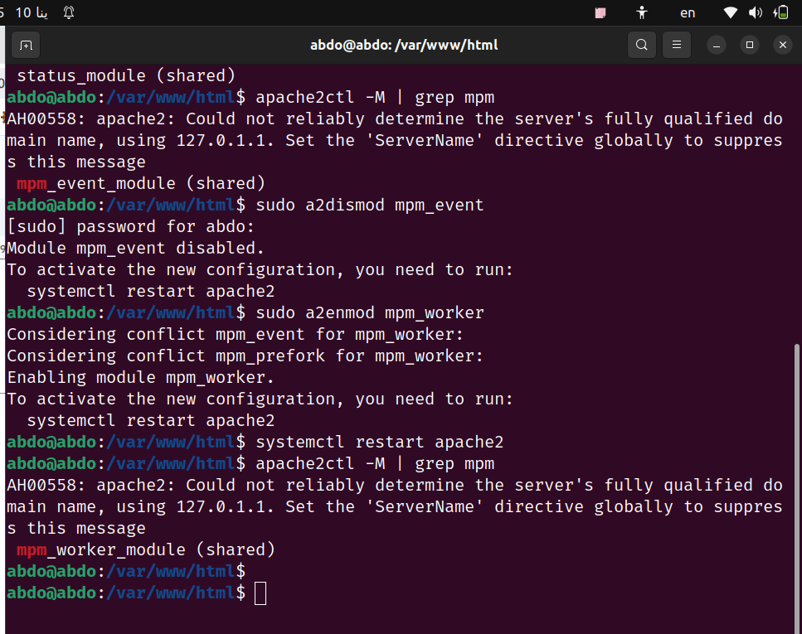

2. Check the status of rewrite_mod and enable it if it is enabled.
apachectl -M | grep rewrite
sudo a2enmod rewrite
sudo systemctl restart apache2
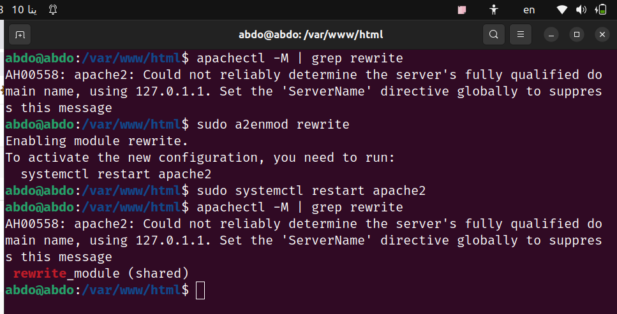

3. Write RewriteCond and RewiteRules for:
Sudo nano /etc/apache2/sites-available/000-default.conf

a. Deny access to http://localhost/page?queryString if queryString contains the string forbidden.

#RewriteCond %{QUERY_STRING} forbidden
#RewriteRule ^page$ - [F]

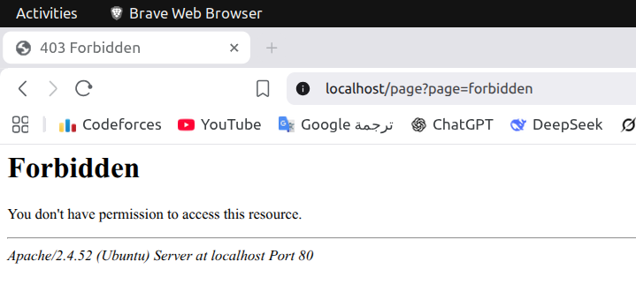

b. Remove the Query String

#RewriteCond %{QUERY_STRING} .
#RewriteRule ^(.*)$ /$1? [R]

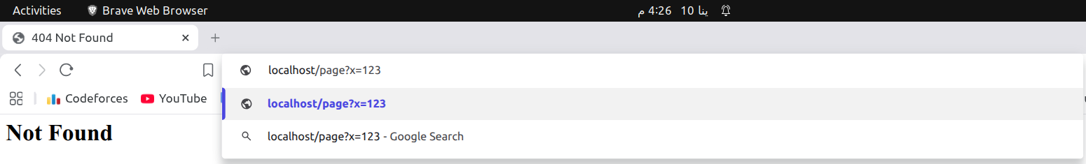


c. Rewrite URLs like http://localhost/page1?var=val to http://localhost/page2?var=val but do not rewrite if val isn't present.
#RewriteCond %{QUERY_STRING} ^var=([^&]+)
#RewriteRule ^page1$ /page2?%{QUERY_STRING} [R,L]

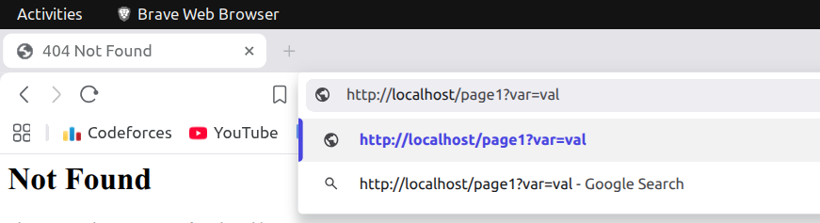



d. Take a URL of the form http://localhost/path?var=val and transform it into
http://localhost/path/var/val.

#RewriteCond %{QUERY_STRING} ^var=([^&]+)
#RewriteRule ^path$ /path/var/%1? [R=302,L]

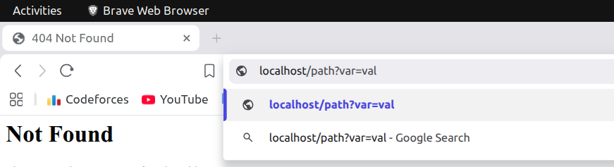



e. Map http://localhost/example/one/two to
http://localhost/something.cgi?arg=one&other=two

RewriteRule ^example/([^/]+)/([^/]+)$ /something.cgi?arg=$1&other=$2 [R=302,L]

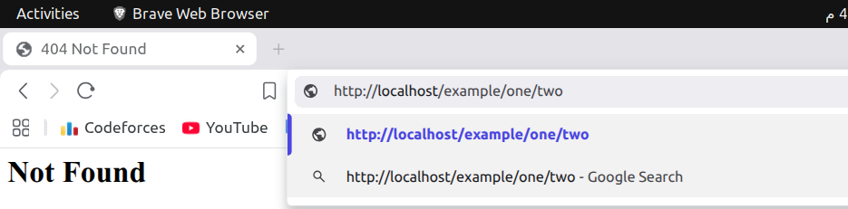


f. (Bonus) Display a goodevening.html page if the time is after 6:00 PM and goodmooring.html page if the time is before that

# Goodmorning before 6:00pm
RewriteCond %{TIME_HOUR} <18
RewriteRule ^time-test$ /goodmorning.html [R=302,L]

# Goodevening after 6:00pm
RewriteCond %{TIME_HOUR} >=18
RewriteRule ^time-test$ /goodevening.html [R=302,L]

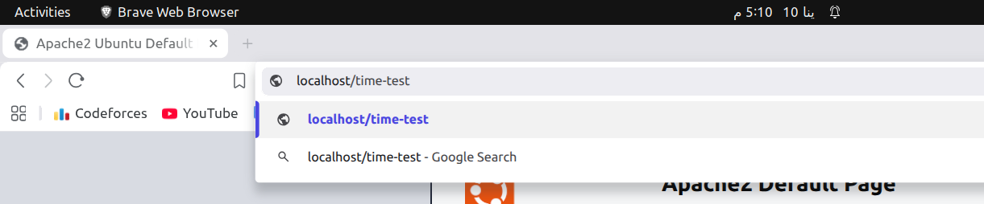

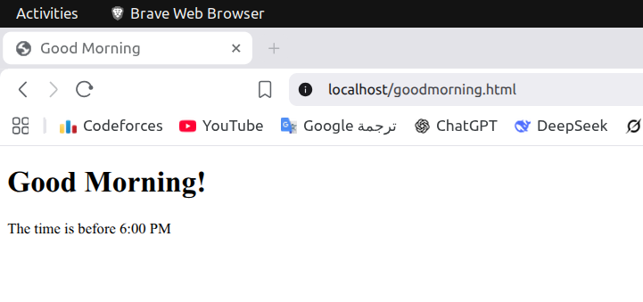
4. Create a virtual host for os.iti.gov.eg to redirect to a local directory in your server

sudo mkdir -p /var/www/os.iti.gov.eg
sudo nano /var/www/os.iti.gov.eg/index.html
sudo nano /etc/apache2/sites-available/os.iti.gov.eg.conf
sudo a2ensite os.iti.gov.eg.conf
sudo systemctl reload apache2

